**BLDK with Inforce Tunnel Creek board**

**v0.3**

**Date: 13th January 2012**

1. ***Hardware information***

The following components are added to the Inforce kit for BLDK University program:

* 320GB notebook hard drive
* SATA cable for notebook hard drive (red color in the image)
* SATA power cable (molex 4 pins)
* Mini fan on the side of the board
* 4 screws for notebook hard drive (M3x6mm)

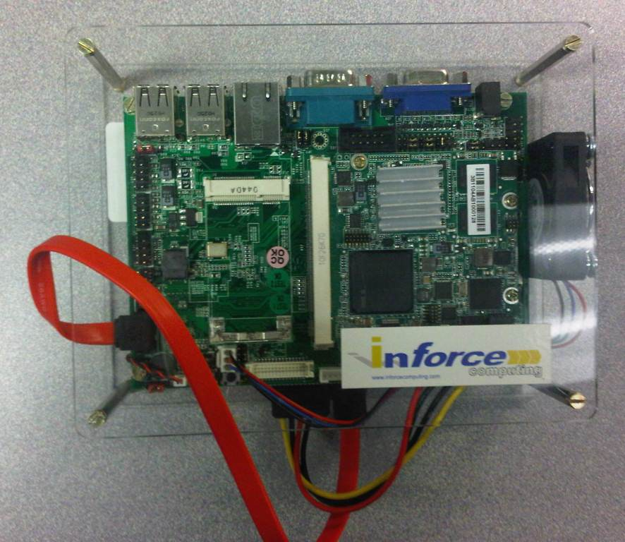

Figure1. Top view 1

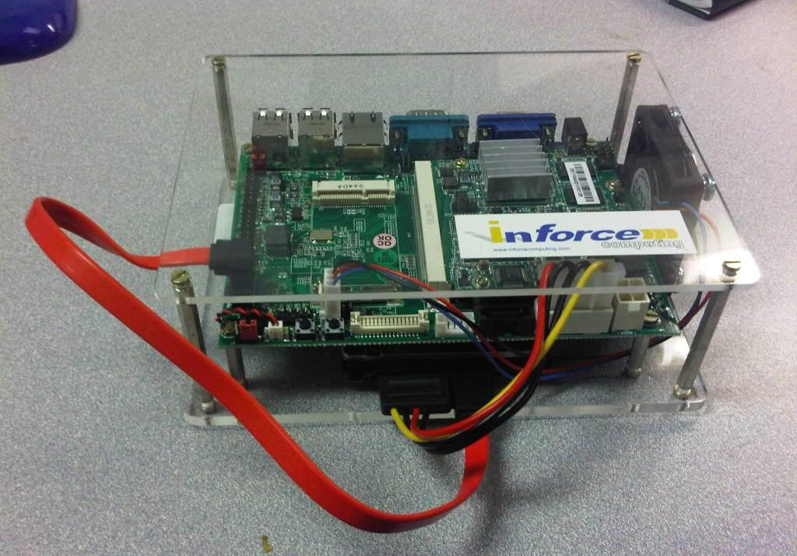

Figure2. Top view 2

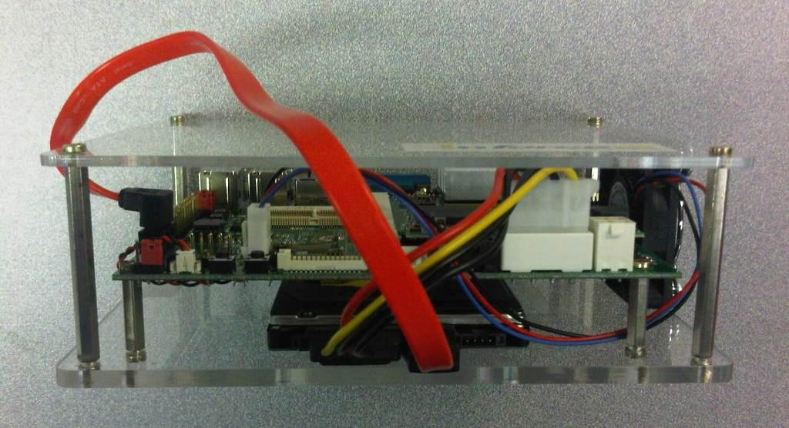

Figure3. Side view

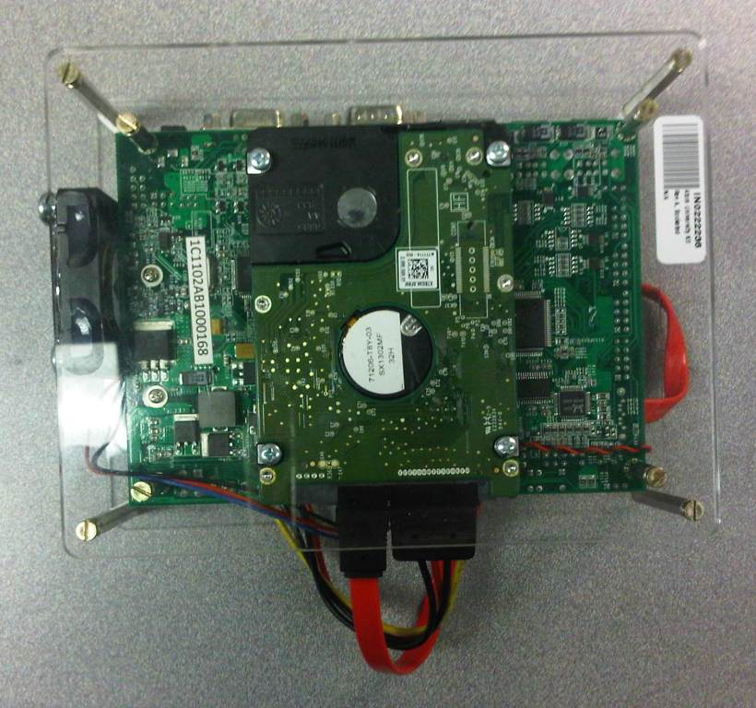

Figure4. Back view

In addition to the above components, the user also needs the following devices to enable BLDK:

* Serial null-modem or USB/Serial adapter to display the EFI shell. In the following example, Belkin F3B207-10 is used as shown below

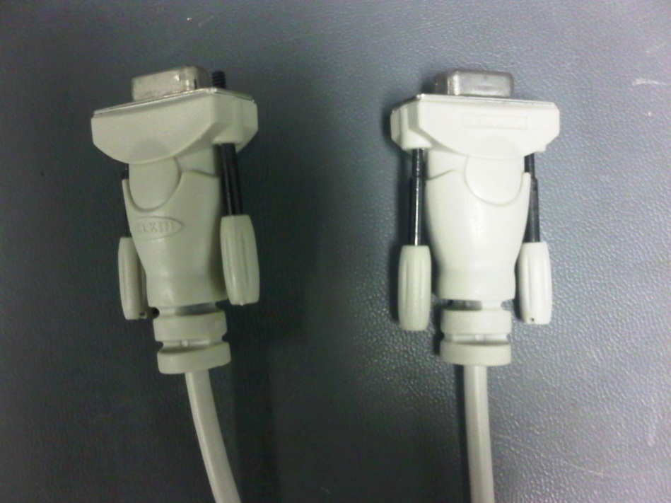

To host PC

To Inforce board

If the host PC does not have serial port, the user needs to use serial-to-USB adapter to connect the null modem. In the following image, Trendnet TU-S9 adapter is used.

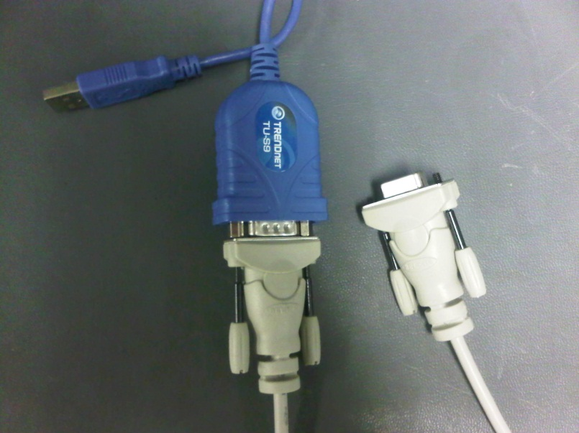

To host PC

To Inforce board

* (OPTIONAL) Dediprog SF100 to flash the BLDK image on the SPI chip on the board.

1. ***Software Information***

The following software is used to bring up BLDK:

* Hyper-Terminal or Putty to display the serial connection. The settings are: 115200, 8, No Parity, 1 stop, no flow control
* (OPTIONAL) Dediprog Engineering software

**Timesys Fedora 11 login information**

If the user use/clone the existing Timeys Fedora 11 drive, the login information is shown below:

**Username: inforce or root**

**Password: inforce123**

*3. Flash BLDK image*

The user needs to use Dediprog tool to flash BLDK image on the Inforce board. Once BLDK image is flashed, the user can use spiupdate command for subsequent update of BLDK image. There are two BLDK images that is available.

* BLDK2 Alpha image: This BLDK image is the Alpha release that is used for the early testing on the Inforce board.



* BLDK2 Gold image: This BLDK image is the Gold release. It is advised for the user to start using this version as many bugs have been fixed with the Gold release.



3.1 Launch Dediprog Software. If the good connection is established between the host PC and the SPI chip, the user should be able to see USB OK green sign as shown in the following

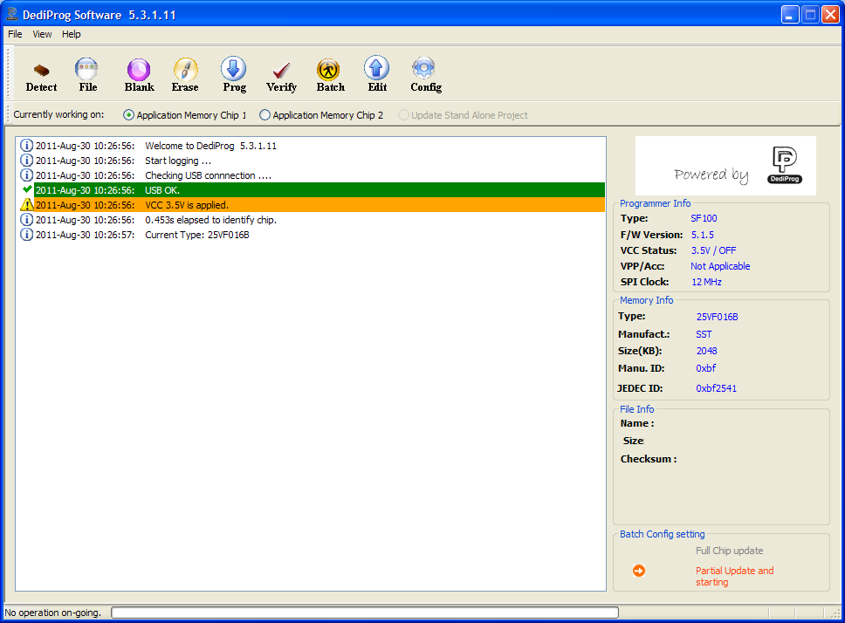

3.2 Click on Config icon. Change the update start from address value from 0x100000 to 0x1FFFFF. Select OK

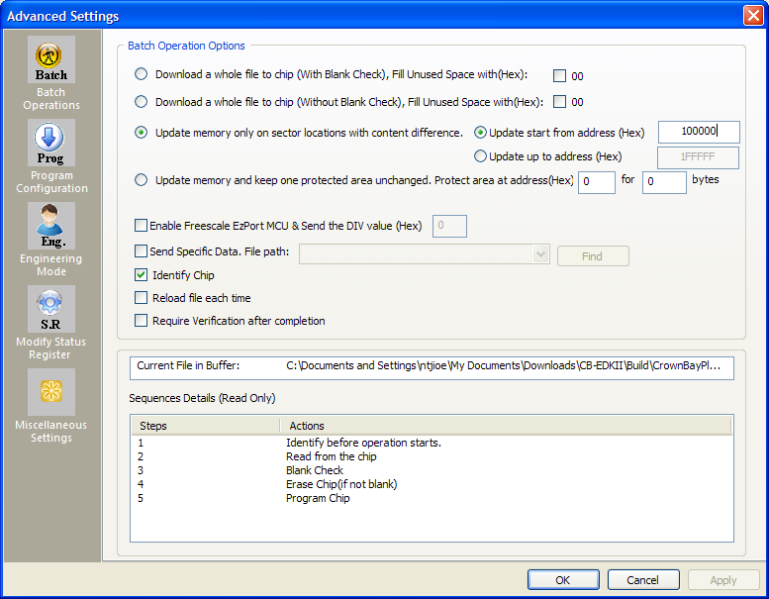

3.3 Click on the Erase icon to eras the whole content of the SPI chip

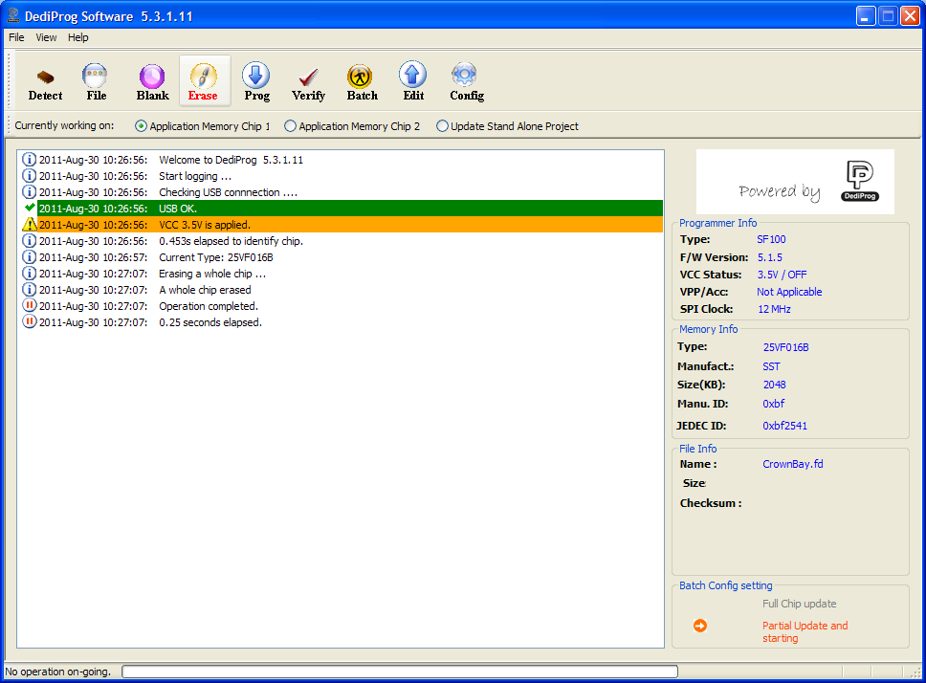

3.4 Click on the File icon to locate the location of BLDK image. It can be in the format of .fd or .rom. Click on the file and select Open

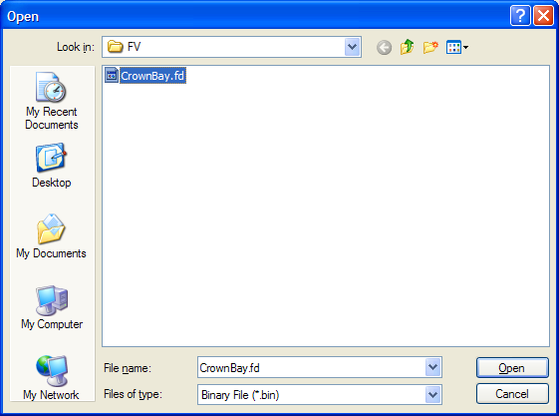

3.5 Click OK in the next window

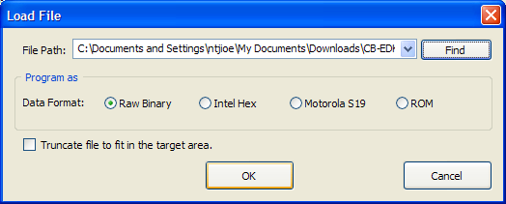

3.6 Click on Batch icon which will do Erase and Program automatically. Once it’s done, user should be able to see green sign of Programmed successful text in the tool.

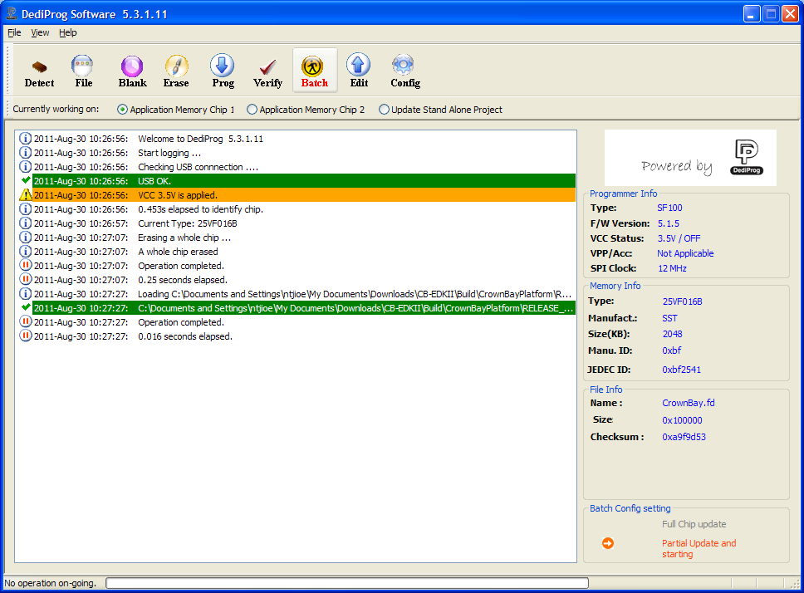

3.7 For verification purpose, it’s always a good practice to click on Verify button to verify the content of BLDK image to see if there is any corruption data. Once it’s verified go to steps 4 to install Timesys Fedora 11/14 OS.

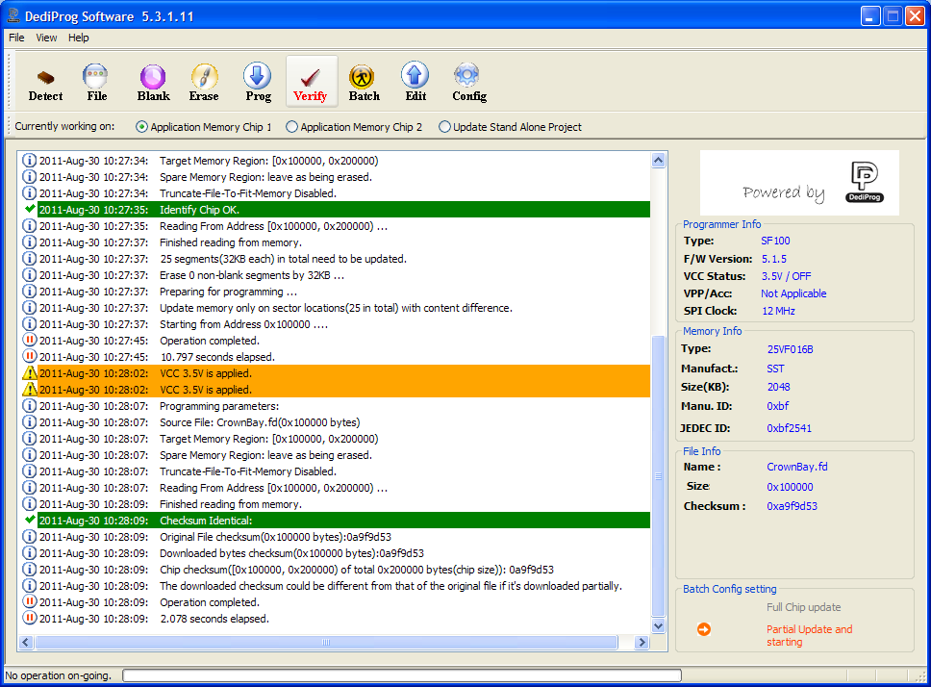

*4.* ***Install Timesys Fedora 14/11 Fedora Linux OS***

There are some changes that user need to make to bring up the existing Timesys image boot with BLD environment. For a new user that interested to learn more about Timesys, you can go to <http://www.timesys.com/> to check Timesystem development.

Timesys 14/11 is a Fedora Remix built for the Intel® AtomTM Processor E6xx Series with Intel® Platform Controller Hub EG20T reference design. The Fedora Remix joins modified and unmodified Fedora software with non-Fedora software, including the Intel® Embedded Media Graphics Driver (EMGD) and kernel modifications for the Intel® Platform Controller Hub.

Before we start the Timesys Fedora 14/11 installation, first the user must build their UEFI loader which is required to boot the OS from BLDK. In this example, the operating system loader used is elilo which the user can get from <http://sourceforge.net/projects/elilo/>. The user should build their elilo binary from another Linux system that runs in 32 bit kernel. In addition, elilo requires another development libraries and tools like gnu-efi, gcc, binutils, autoconf and versions. Please use yum to install this from Fedora repository. Here are the steps:

**Note: If user wish to use the existing prebuilt elilo.conf and elilo.efi for Timesys Fedora 14/11, please jump to step number 4.8**

* 1. Download elilo-3.14-all.tar.gz from <http://sourceforge.net/projects/elilo> and save in a local directory.
  2. Save the elilo-3.14.patch in the same directory as the elilo folder



* 1. Unpack the whole elilo source tree using the command: tar xzvf elilo-3.14-source.tar.gz
  2. Apply the elilo patch using the commands below. Note that the patch uses relative paths so ensure you carefully follow the above steps.

*cd elilo patch -p1 < ../elilo-3.14.patch*

* 1. Build elilo.efi using the following commands:

*make clean*

*make*

* 1. The user need to rename elilo.efi to OemBootOption.efi since BLDK will only recognize OemBootOption.efi when it look for the boot loader. This will be explained in later section.
  2. elilo.efi work in parallel with its configuration file to automate the operating system boot process. The configuration file called elilo.conf will help elilo.efi to locate the correct kernel location. More information for elilo.conf can be obtained from elilo/docs directory.
  3. For Timesys Fedora 14, here is the elilo.efi and elilo.conf:

 

For Timesys Fedora 11, here is the elilo.efi and elilo.conf:



* 1. Copy elilo.conf and OemBootOption.efi to a USB drive where we will copy this file for later use on the target system.

In the next steps, the user needs to install Timesys Fedora14/11 image on other platform. Here are the steps:

**Note: Timesys Fedora 14 is much more convenient to bring up on Inforce board since EMGD graphic driver (v2032) is built in to the image. The user does not need to install EMGD graphic driver separately. Timesys Fedora 11 does not come with EMGD graphic driver as a result more work is needed to bring up GUI display on the Inforce board.**

**In addition, Timesys Fedora 14 comes with GCC 4.5.1 which supports Atom architecture optimization by using –march=atom and –mtune=atom option in the GCC flag. Timesys Fedora 11 comes with GCC 4.4.1 only which DOES NOT support any Atom software optimization.**

* 1. To install the Timesys 14/11 Fedora Remix, the Timesys 14/11 installer must first be downloaded and then loaded to DVD. The ISO image can be downloaded from <https://linuxlink.timesys.com/intel/linux>.
  2. As the ISO is several GB in size, the installer is broken into several chunks which can be rejoined from the command line. In this example, Timesys-14 is used. From the Linux terminal, run:

# cat Timesys-14-i386-DVD.iso* > Timesys-14-i386-DVD.iso

From the Windows Command Prompt, run:

# type Timesys-14-i386-DVD.iso* > Timesys-14-i386-DVD.iso

* 1. The output ISO will be the full graphics-based ISO that needs to be burned to DVD image (~2-3 GB). Use your local computer to burn this ISO image to DVD.
  2. Setup the Crown Bay platform (preferred) to install Timesys OS by following the steps below:
     1. Attach SATA CD/DVD drive to Shell Bay SATA port
     2. Attach SATA Hard disk drive to Shell Bay SATA port
     3. Connect graphical display, such as an Intel® SDVO device, LVDS display, or third party graphics device. Notethat not all displays are supported by EMGD.
     4. Boot the board.
     5. Enter BIOS setup. For the American Megatrends AMBIOS, press <Delete> or <F2> from the AMBIOS splash screen to do this.
     6. Open the CD/DVD drive and insert installation media.
     7. Select SATA CD/DVD drive as the primary boot device from BIOS setup.
     8. Save your settings and exit BIOS configuration .
     9. If the hardware and BIOS have been properly configured, you should see the Timesys 14 installer splashscreen.
     10. Select Install a new system -> Basic Storage Devices.
     11. Check Create Custom Layout option to configure the partition.
     12. These steps are very crucial to bring up Timesys OS with BLDK environment. Correct file system partition must be setup for BLDK to boot the OS. Delete any existing partition on your hard drive and configure your hard drive to follow the same partition as shown below. In this example, 80 GB hard drive is used. The user is free to determine the size that they desire for each partition.

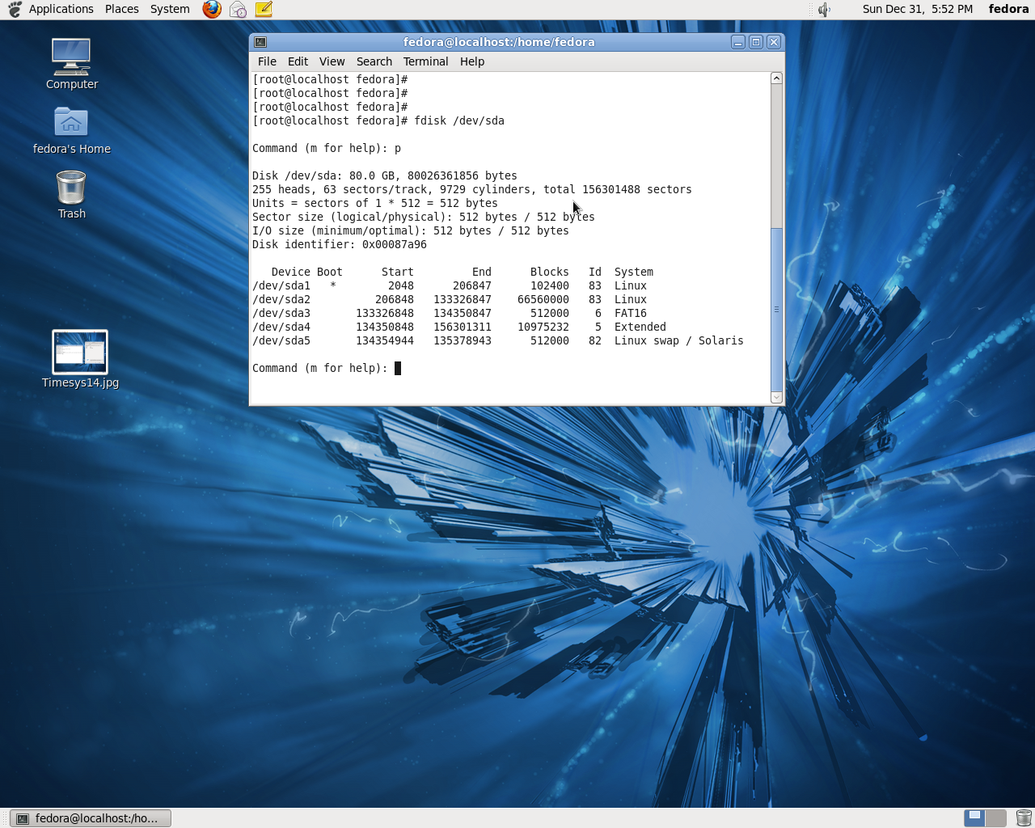

* + 1. Complete the Timesys installation and reboot the system to boot to the OS.
    2. Mount the vfat partition (/dev/sda3 in above example) using the following command.

*mount /dev/sda3 /mnt*

* + 1. Create a folder named efi. Inside efi folder, create a folder named oem as shown below

*cd /mnt*

*mkdir efi*

*cd efi/*

*mkdir oem*

*cd oem/*

The reason why we need to create /efi/oem folder inside /dev/sda3 is because BLDK image by default, will go to that folder to look for the boot loader to boot the OS image. The user can change the directory of the Oem Boot Option path inside the BLDK kit under Boot Setup option. Once user made the changes, they need to rebuild the BLDK firmware and update the SPI chip on the Inforce board.

* + 1. User will need to copy the kernel and initrd image to efi/oem/ folder using the following commands

For Timesys Fedora 14,

*cp /boot/vmlinuz-2.6.35-8 .*

*cp /boot/initramfs-2.6.35-8.img .*

For Timesys Fedora 11,

*cp /boot/vmlinuz-2.6.29-11 .*

*cp /boot/initramfs-2.6.29-11.img .*

At the minimum, 4 files need to present inside /efi/oem folder (elilo.conf, OemBootOption.efi, vmlinuz image and initramfs image).

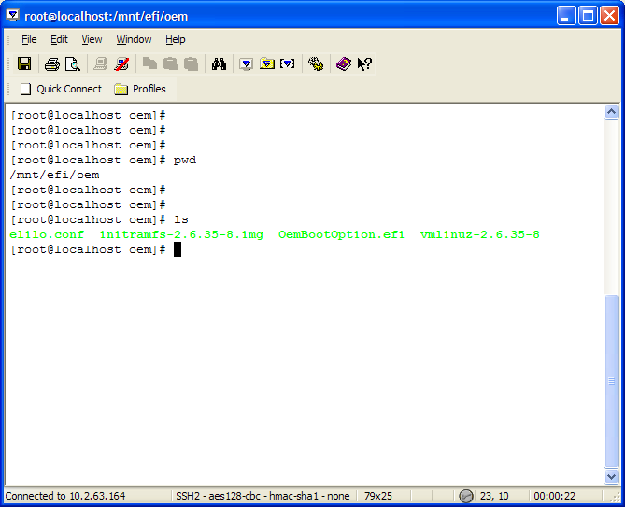

* + 1. Go to /etc/x11 folder and copy over the below xorg.conf to the folder.



Without the correct xorg.conf, GUI display and EMGD driver will not start

* + 1. If the user is using Timesys Fedora 14, the user can reboot the system and go to section 5 to start booting Timesys Fedora 14 OS

If the user is using Timesys Fedora 11, please install kernel-devel, kernel-headers package through yum as we will need to recompile EMGD driver to install it on the OS. Please contact me separately of how to recompile the EMGD driver after you have the above required libraries installed.

1. ***Timesys Fedora 14/11 boot process***

If user prefers to use Hyper-Terminal instead of Putty, they can skip the following steps and go to section 5.2

* 1. *Putty*
     1. Download and install Putty (<http://www.chiark.greenend.org.uk/~sgtatham/putty/download.html>)
     2. To find which COM port to use, open Device Manager, and scroll down to Ports (COM & LPT)

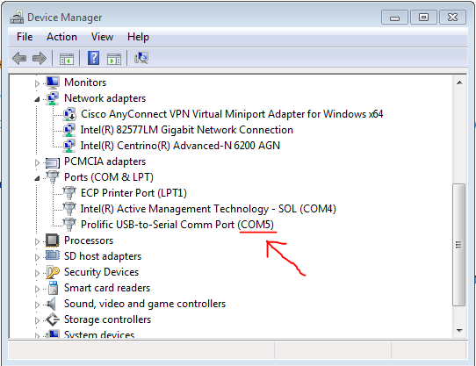  
In this case, we will be using a USB-to-Serial adapter, so we will select port COM5

* + 1. Open Putty, and select the Serial menu option on the left. Enter your port in the first line, and make sure all the following fields match the screenshot below.

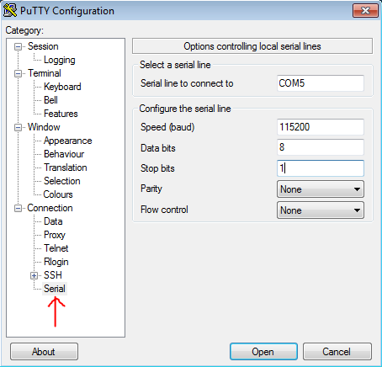

* + 1. Make sure your serial cable is connected from your PC to the Inforce board’s serial port, and click “Open” in Putty.
    2. Putty will open a blank black window. Press the power button on your Inforce board.
    3. Go to section 5.3
  1. *Hyper-Terminal*

* + 1. Launch Hyper-Terminal
    2. Type in the desired name for the new connection in Hyper-Terminal. In this example, “inforce” is the name of the new connection.

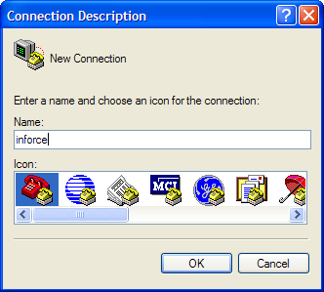

* + 1. Select the correct COM port from the device manager.

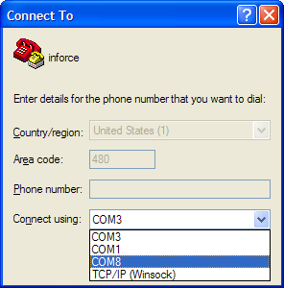

* + 1. Fill in the Hyper-Terminal settings as shown in the following

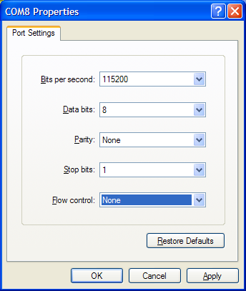

* + 1. Power on the Inforce board and go to section 5.3
  1. *EFI Shell*

5.3.1 In this section, the user will bring up Timesys Fedora 11/14 OS from the EFI shell.

When Inforce board is powered on, the user will see the following screenshot appear in Hyper-Terminal/Putty window where the platform information as well as the BLDK version is displayed.

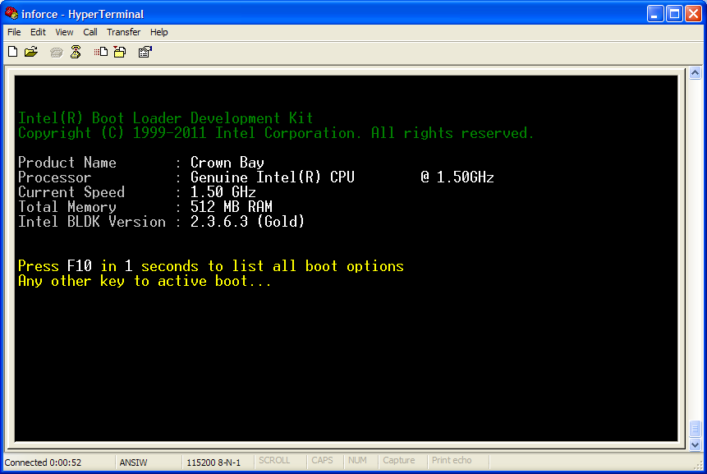

**BLDK Version**

5.3.2 To boot Timesys Fedora 11/14 OS, the user can hit ESC key to go to EFI Shell. In the EFI Shell, all of the block device information will be displayed. Please type “exit” in the shell.

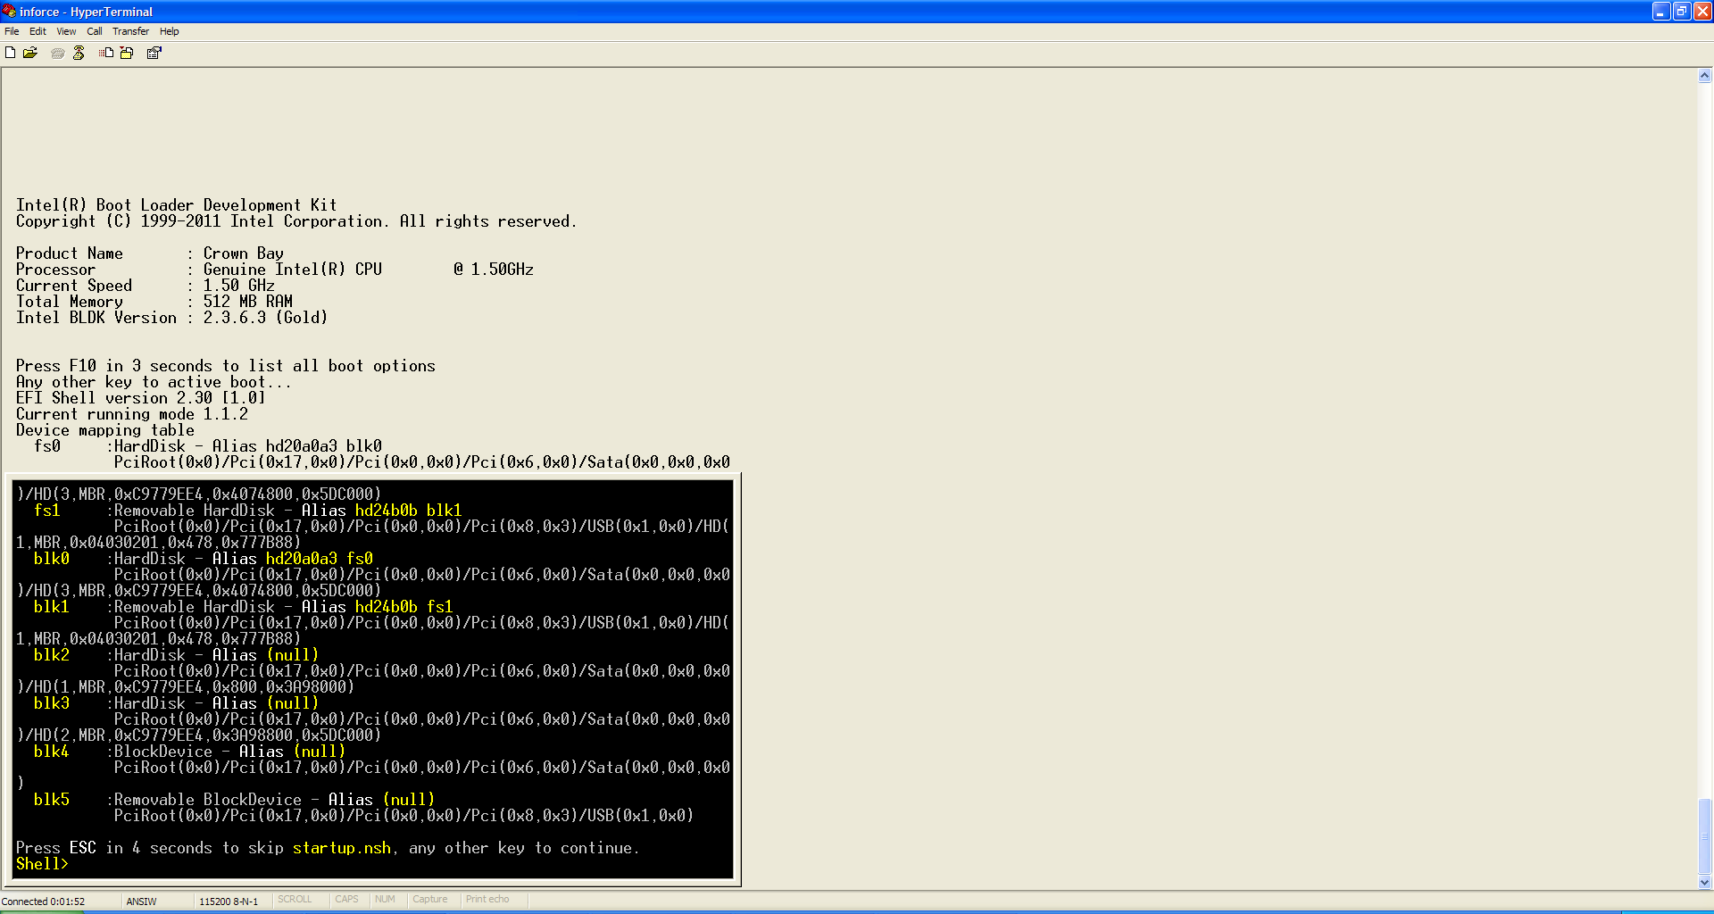

5.3.3 The user will start to see “Enumerating boot devices” text where it will bring the user to the Boot Options screen as shown below.

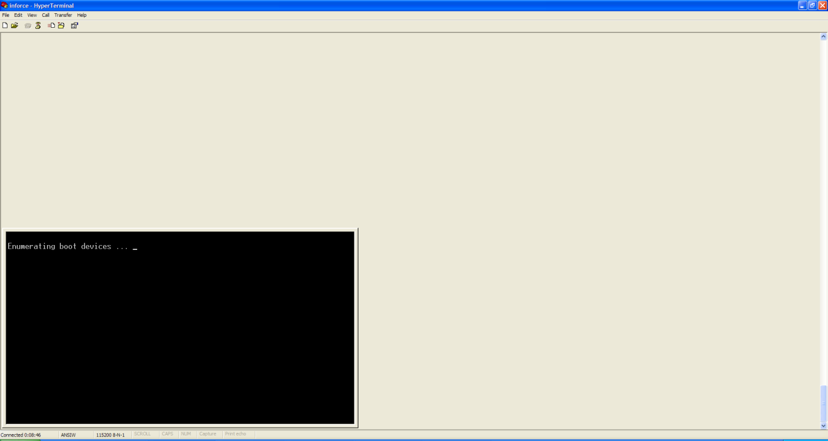

5.3.4 In the Boot Options screen, please select number 2 to boot Timesys Fedora 11 /14 OS. The user can always go back to EFI Shell by pressing number 1. “EFI Internal Shell” and “EFI Payload” will always be displayed, regardless of which devices are connected.

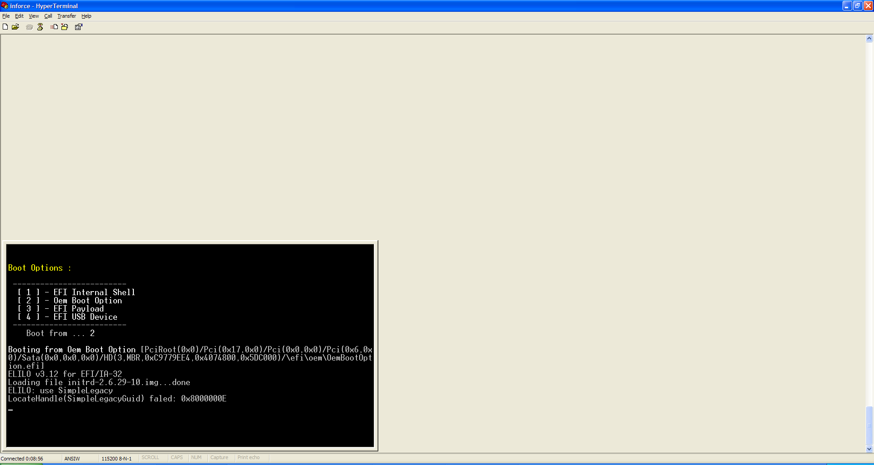

**Note: The user need to do this only once when the system is powered on with BLDK image if they do not change the hard drive. For the subsequent reboot, BLDK will remember the OemBootOption and boot from the hard drive directly. Every time, the user switches hard drive, the user needs to select Oem Boot Option again.**

5.3.5 The user will see tons of Linux print out when Timesys Fedora 11/14 OS boot. After inserting over stolen memory message is seen on the screen, the user will be able to see GUI display from the VGA port of the Inforce board as shown below

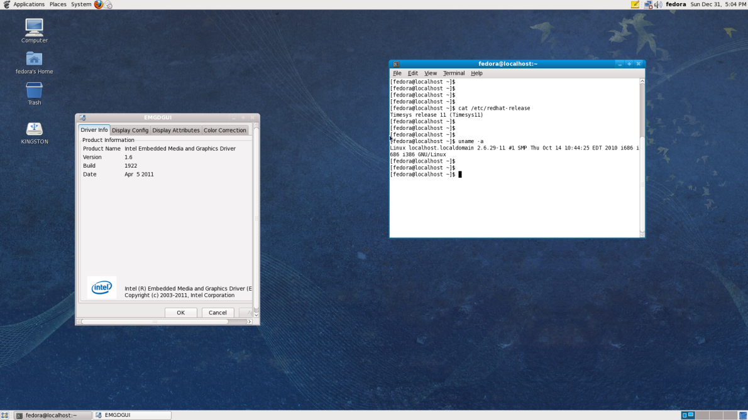

Timesys Fedora 11

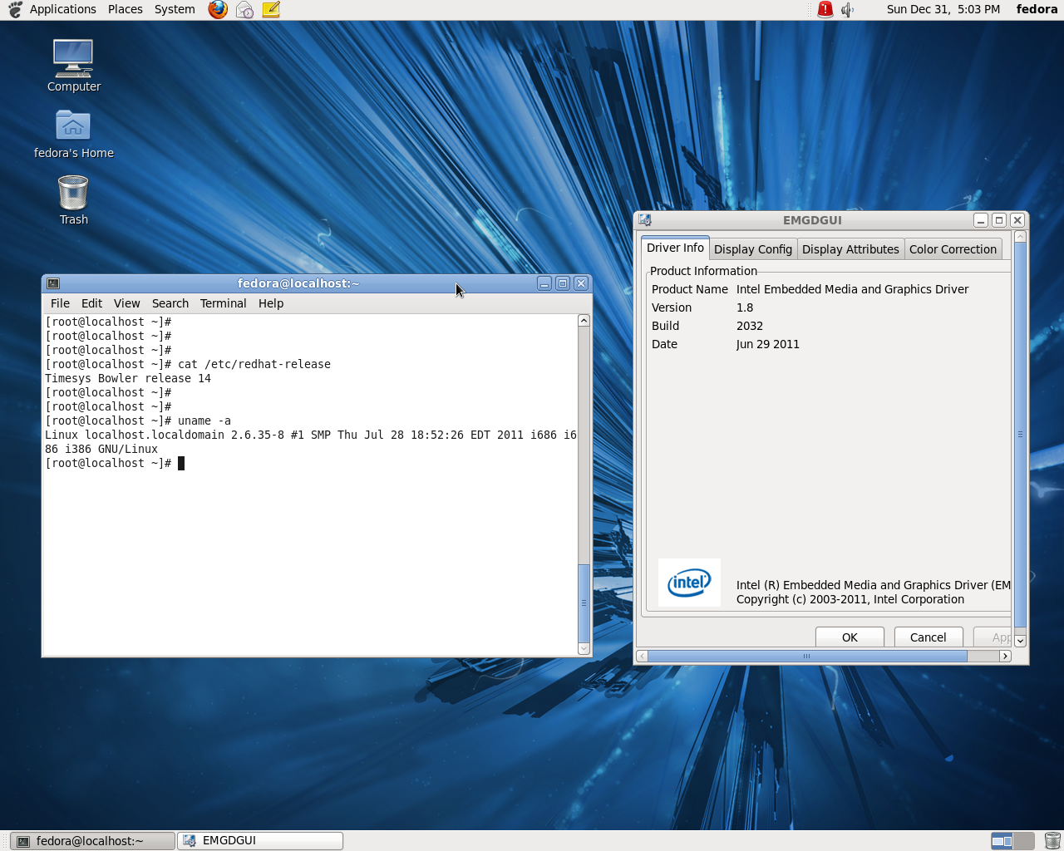

Timesys Fedora 14

1. ***SPIUPDATE in EFI Shell***
   1. *USB thumb drive*
      1. There are couple ways to update the firmware on the Inforce board. In this section, we will use SPIUPDATE binary to avoid external programmer usage. Go to the following site to download HP USB Disk Storage Format utility.

<http://download.cnet.com/HP-USB-Disk-Storage-Format-Tool/3000-2094_4-10974082.html>

* + 1. Extract the binary and proceed with the installation .

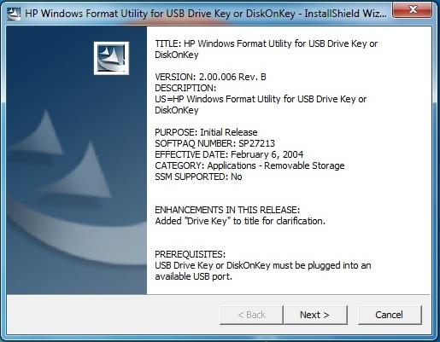

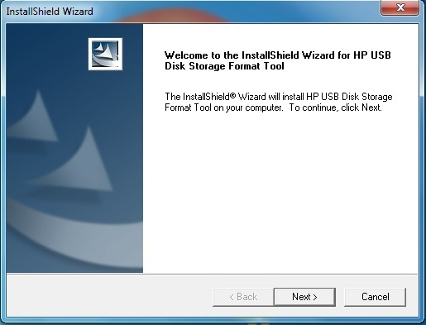

* + 1. Once the utility is installed, plugged in any USB thumb drive to the host PC. Start the HP USB Disk Storage Format utility as shown below.

Make sure that the “FAT 32” is selected in the File System option. Click on the Start button to start formatting the thumb drive.

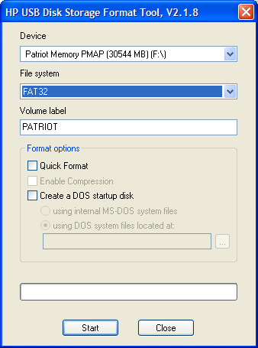

* + 1. It will take couple seconds for the formatting process to be done. Once it’s done, the following image should be seen. The drive is ready to be used now.

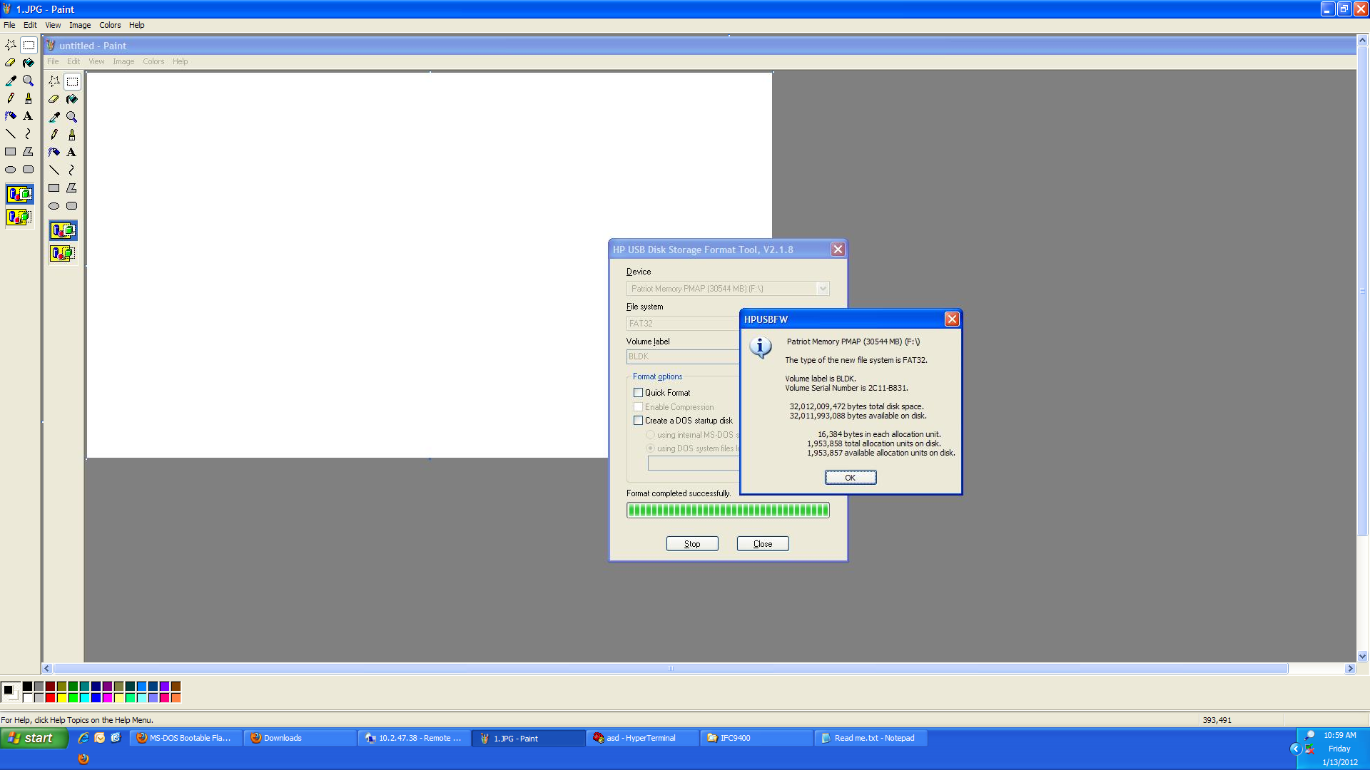

* 1. *BLDK Image Update*

If the user is interested to update the firmware from BLDK to BIOS, jump to section 6.3.

* + 1. Setup the desire serial application from section 5.1 or 5.2
    2. For subsequent BLDK flash process, user can use SPIUPDATE command to update the BLDK image
    3. Copy firmware image (*.rom) and firmware update tool (SPIUPDATE.efi) to USB thumb drive
    4. Insert USB thumb drive to the Inforce board and power on the board
    5. In the EFI shell, type in the command “map –r” and select the one that has the label “Removeable HardDisk”
    6. Type in the label of the “Removeable HardDisk” in the EFI shell. In this case it will be “fs1:”

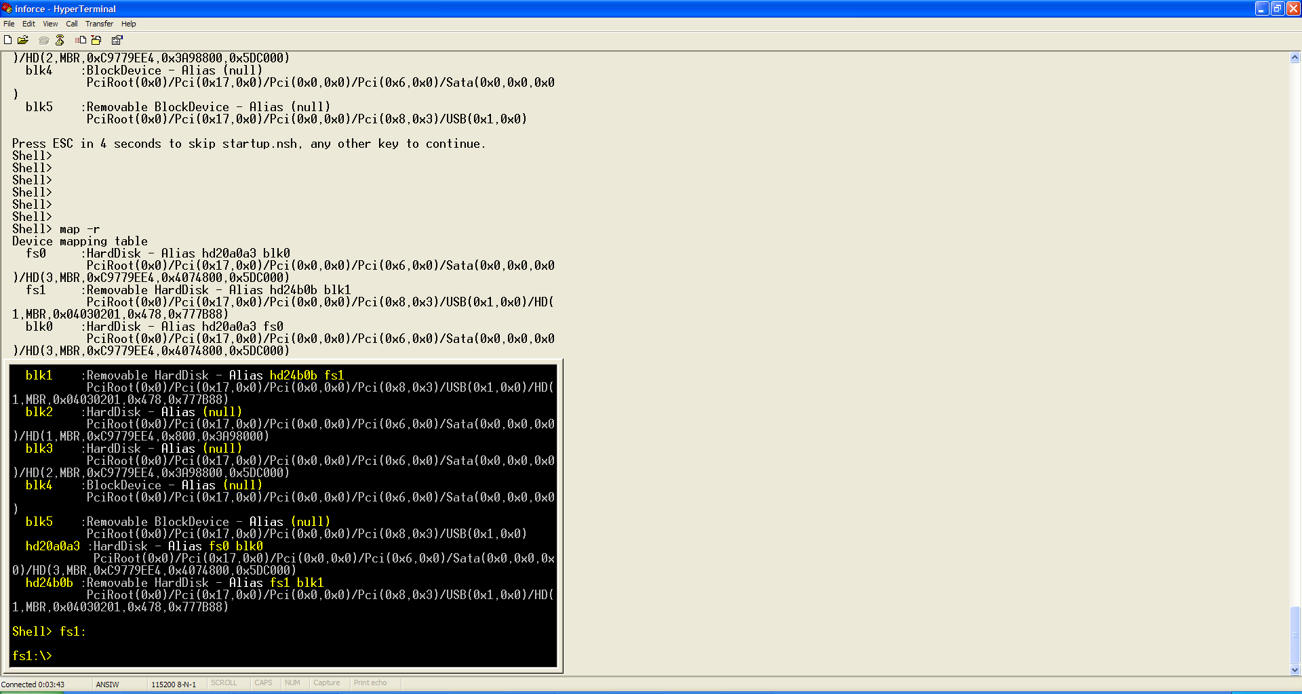

* + 1. Issue the following command to start the SPI update process. “spiupdate nameofromimage.rom”. Once the firmware update successful text appear on the console, power cycle the system to ensure the changes are made. Power on the system to use the updated BLDK image.

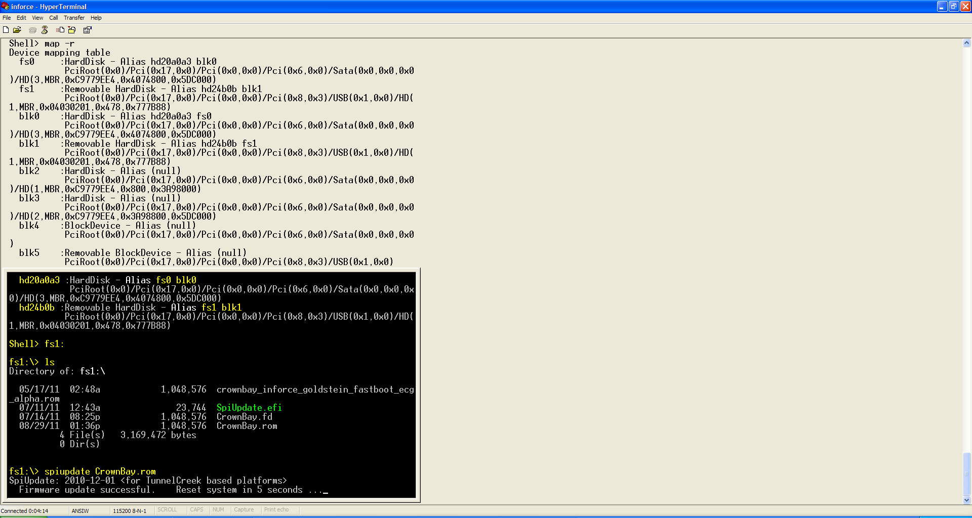

* 1. *BIOS Image Update*
     1. Extract the following zipped file that contains BIOS image to the local folder in the host PC



* + 1. The zipped file should contain the following files. Copy both of the files to USB thumb drive in the Host PC.

**IFC940X_revp1.bin is the current PHOENIX BIOS evaluation version provided by Inforce**

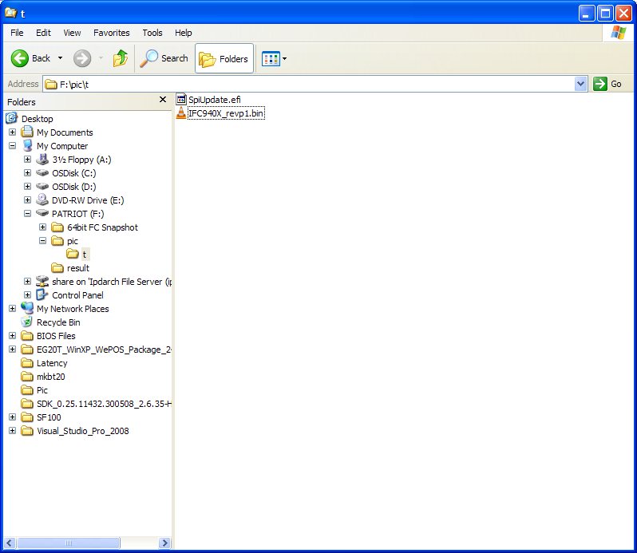

* + 1. If the BLDK image is currently flashed to the Inforce board, remove all SATA connections and plug in the USB thumb drive to the Inforce board.

**Please be aware that the user will need to ship back their board if they need to switch back to BLDK from BIOS. User can still use the following steps to update the future BIOS to their Inforce board.**

Power on the board and start the desired serial application from section 5.1 or 5.2. A blinking cursor follow by EFI shell should appear in the application.

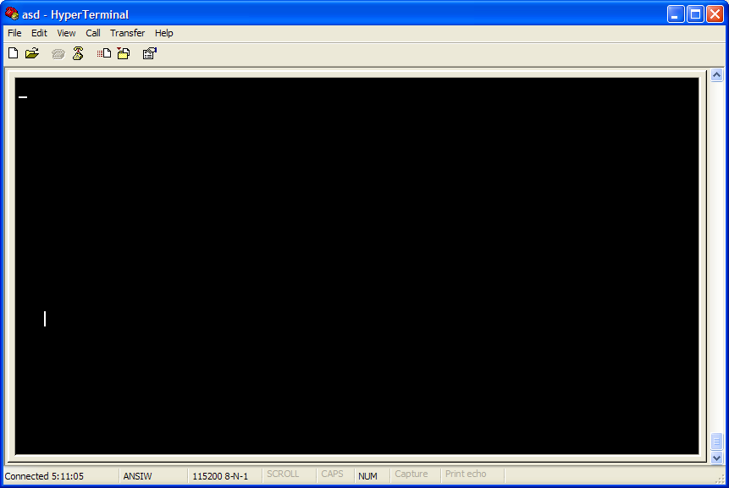

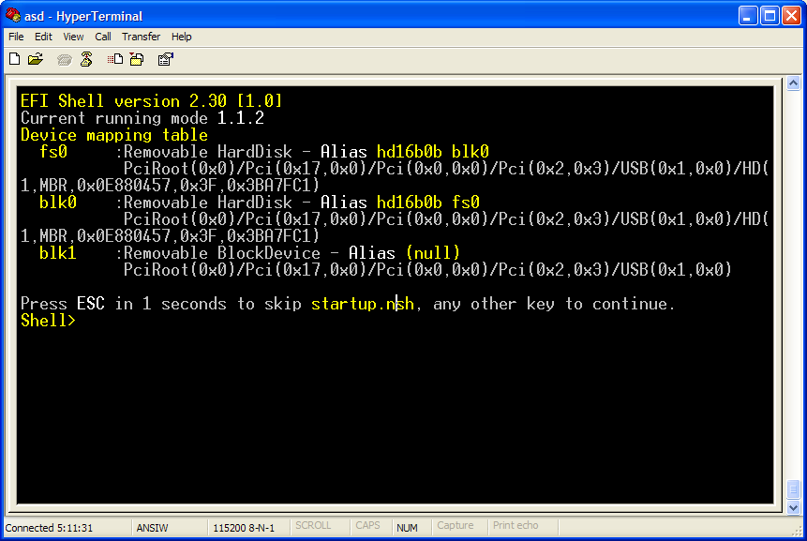

* + 1. Type in the command “map –r” inside the EFI shell to list all of the block devices available in the Inforce board. FS0 is the device name for the USB thumb drive that we plug in to Inforce board.

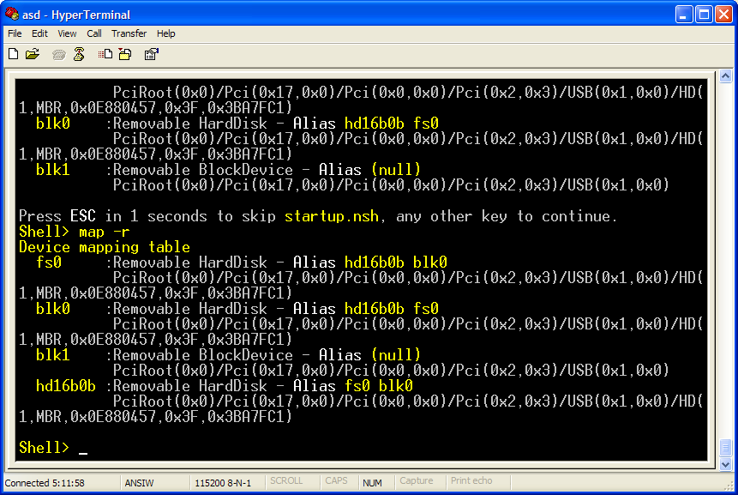

* + 1. Type the command “fs0” (it may be different for the user) in the shell. Do “ls” to verify that the file that we want to use is present in the USB thumb drive.

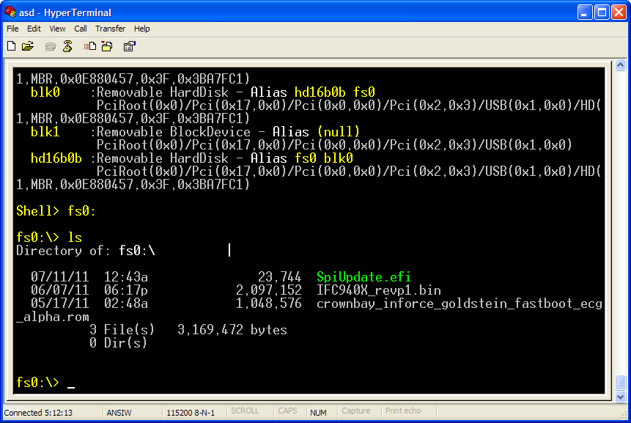

* + 1. In this step, we will issue the following command in the shell to start the firmware update process. The process will take couple minutes.

SpiUpdate.efi <space> IFC940X_revp1.bin

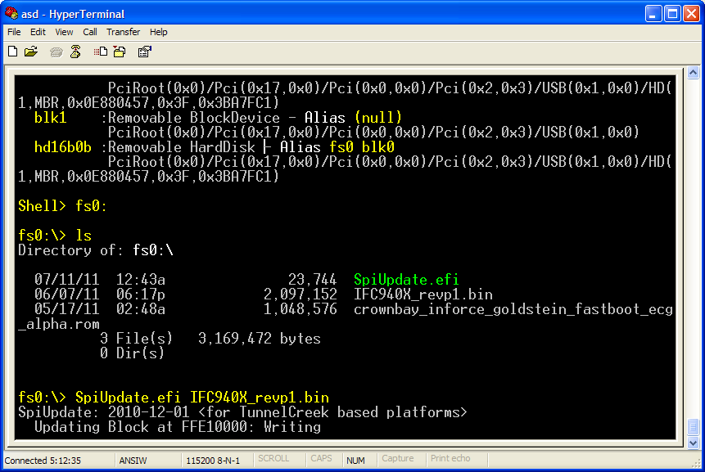

* + 1. If the firmware update process is successful, the following text should be seen in the shell “Firmware update successful”. The system will reset in 5 seconds and after it resets, it will start use BIOS firmware as shown below.

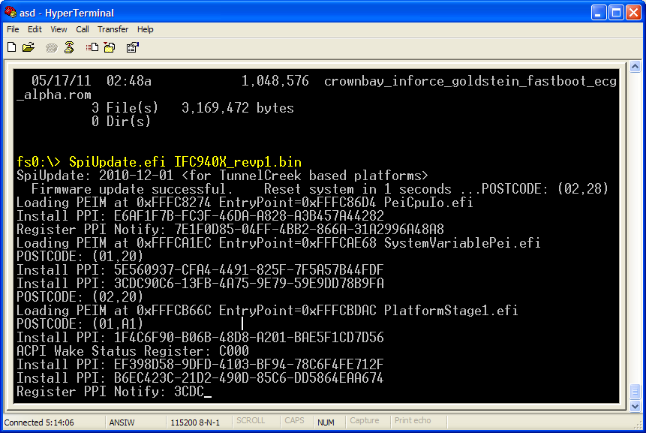

* + 1. When the BIOS firmware boots, the user should see the following text appear briefly in the left upper corner of the screen.

|  |
| --- |
| Intel EMGD Video BIOS  CSWL Config Settings  RPC  1 |

* + 1. Now, the user must update their BIOS time and date to avoid System CMOS Checksum error as shown below. Press F2 to go to BIOS setup.

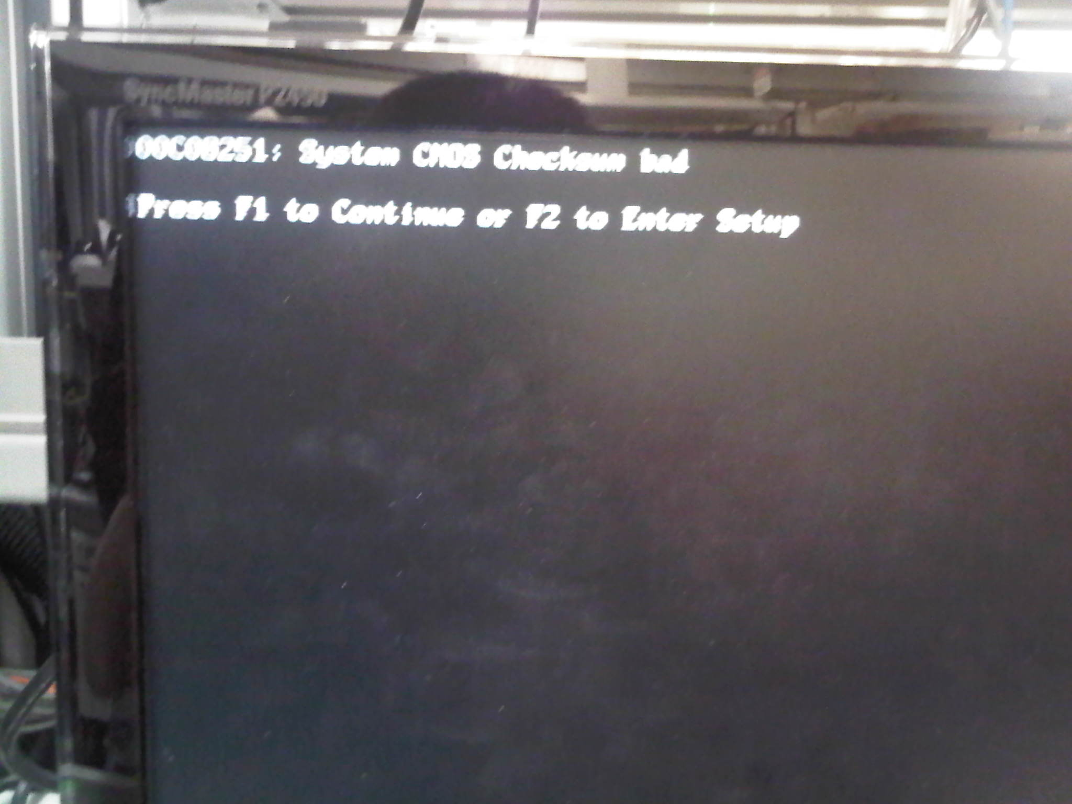

* + 1. Change the System Date and Time as shown below. Press F10 to save the changes and the system will reboot.

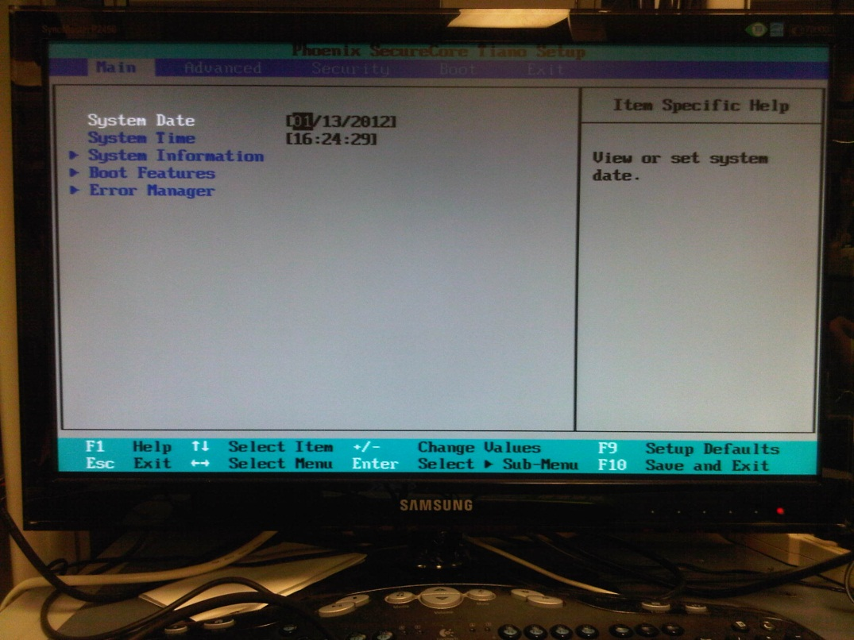

* + 1. After the system reboot, the user should see Phoenix BIOS splash screen that is shown below. Press F2 to go to the BIOS screen if the user wants to make any system change(s).

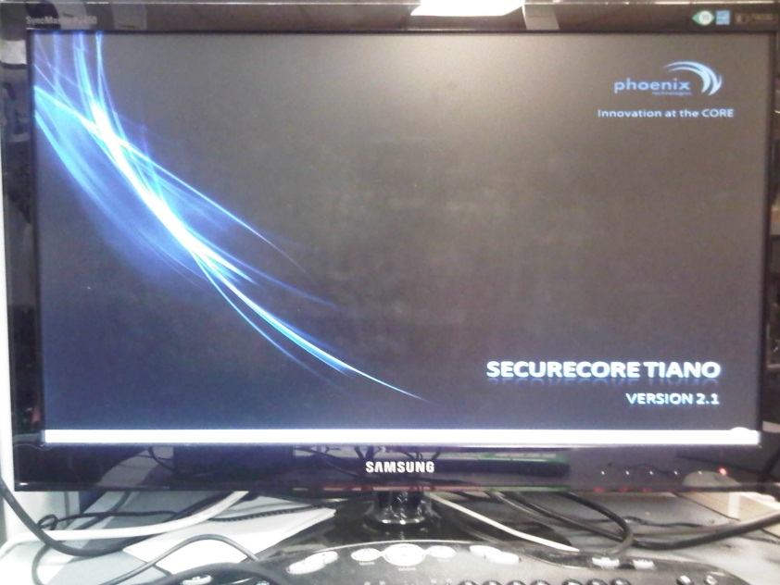

1. ***Install Windows XP SP3***

*7.1 Windows XP SP3 installer configuration*

7.1.1 In the following example, external USB DVD/Bly-Ray drive is used to install the Windows XP SP3 image.

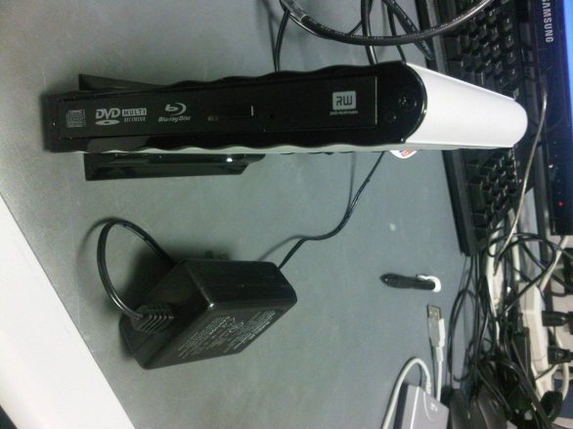

In addition, the user MUST have floppy drive before they can start to install Windows XP SP3 installation. The reason for this is the Intel® PCH EG20T SATA does not support an IDE interface that is compatible with legacy drivers and Windows XP* SP3 does not contain the required SATA AHCI driver natively.

The example USB floppy drive is shown below.

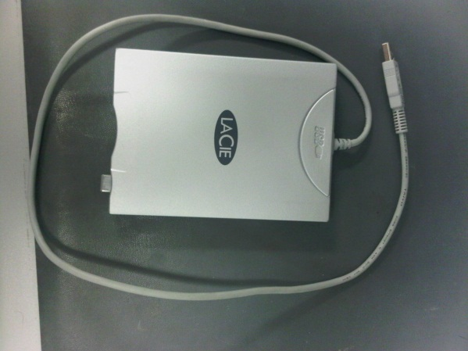

7.1.2 Extract the following zipped file to the local folder in the host PC. Plug-in USB floppy drive (with diskette) to the host PC. Copy over the contents of the files to the **ROOT** of external USB floppy drive.



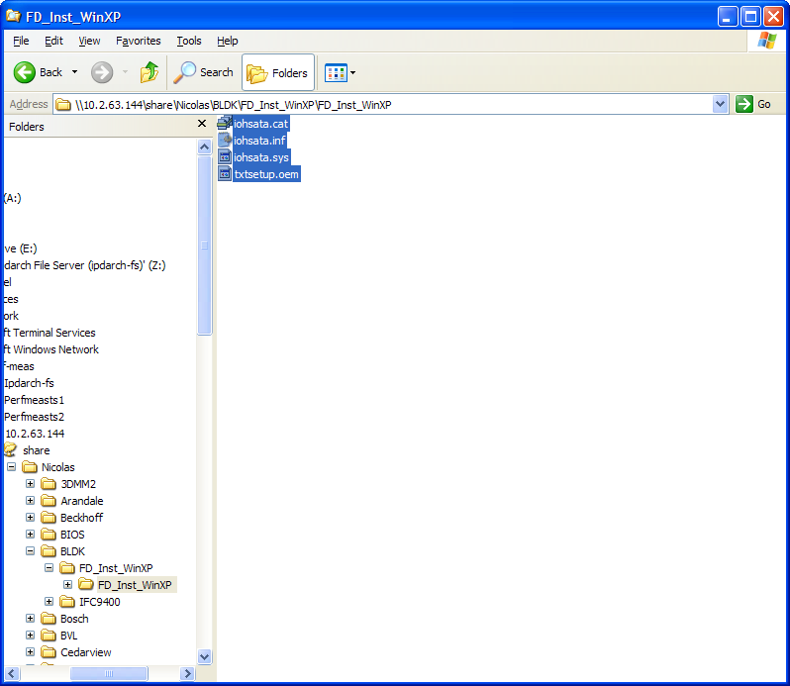

After the files are copied, remove the external USB floppy drive from the host PC. Plug in the external USB floppy drive to the USB port of the Inforce board.

7.1.3 Power on the system and go to the BIOS screen by pressing F2. Inside the BIOS, go to “Boot” tab and ensure that the external USB DVD drive is selected as the 1st Boot Priority Order. Press F10 to save the changes. The system will reboot.

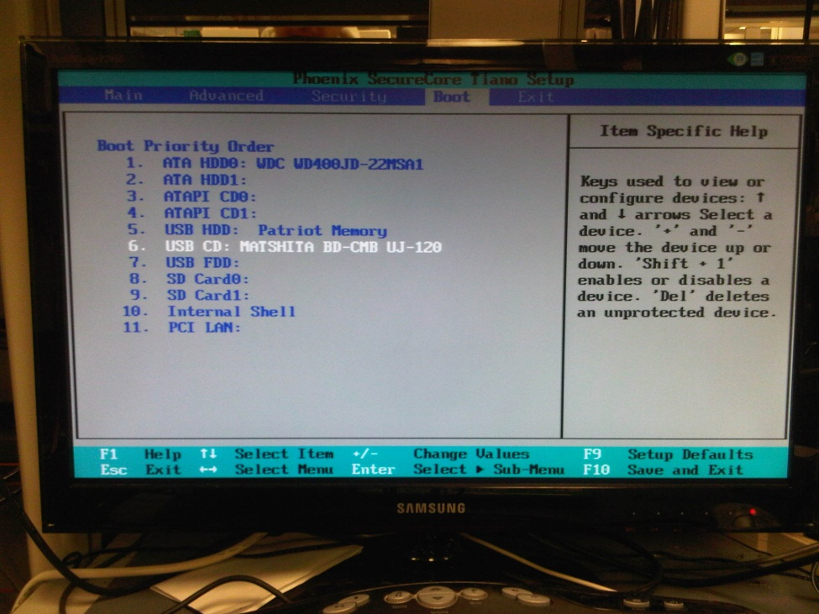

7.1.4 User must follow the following steps to install Windows XP in the Inforce board. Slipstreaming Windows XP SP3 image with Silicon Image drivers will not work.

7.1.5 Insert the Windows XP* SP3 installer CD into the external DVD from. Start the Windows XP* SP3 installation.

7.1.6 The following error will appear. Press <F6> to add further SCSI/RAID drivers when prompted during the very early stage of the Windows installation.



7.1.7 Press <S> to add an additional SCSI device.

7.1.8 Select the correct driver (Intel® PCH EG20T SATA AHCI Controller for Windows XP) and press <ENTER> to continue the installation. This will install the Intel® PCH EG20T SATA AHCI controller driver.



* + 1. During the Windows XP installation, the user will be prompted with several warnings that say it has not passed Windows Logo testing. Hit Yes to continue software installation.

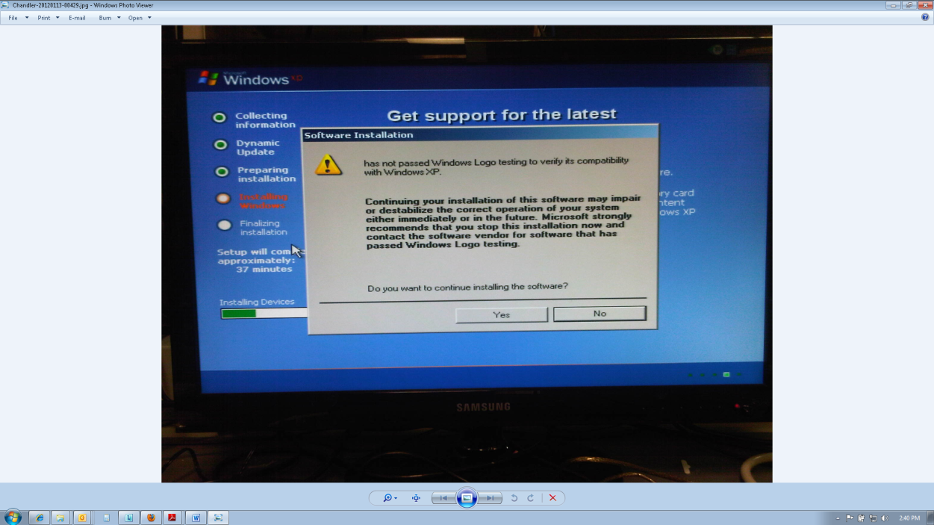

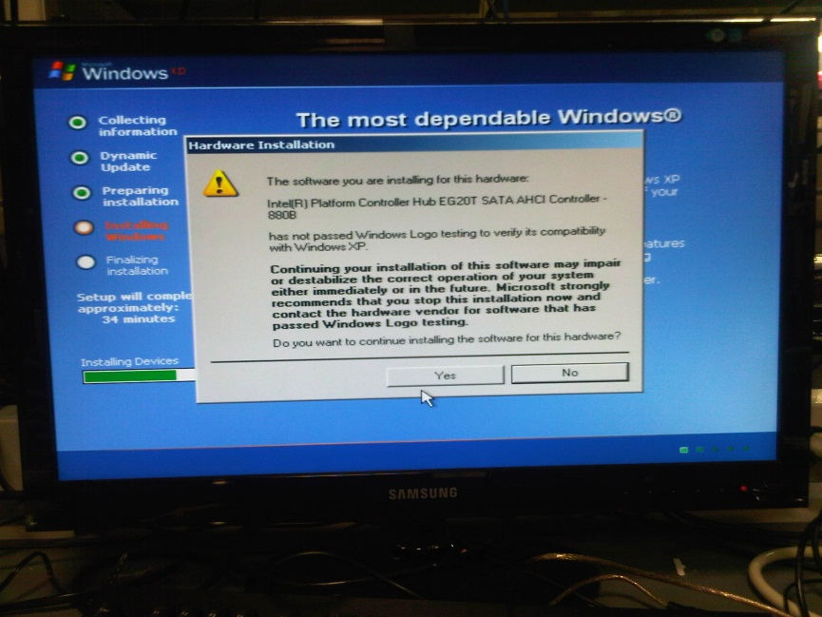

* + 1. Finish the Windows XP* installation according to your needs.
  1. *Windows XP SP3 EMGD driver installation*
     1. After Windows XP is properly installed, go to the host PC that has internet connection and go to the following links to download Intel EMGD graphic drivers.

<http://www.intel.com/p/en_US/embedded/hwsw/software/emgd>

* + 1. Plug-in USB thumb drive to the host PC. In the EMGD site, click on “Download Now” tab. Select “Intel Atom Processor E6XX Series” in the architecture option and select “Windows XP SP3” as the operating system. Click on “Download” button and save it to the thumb drive

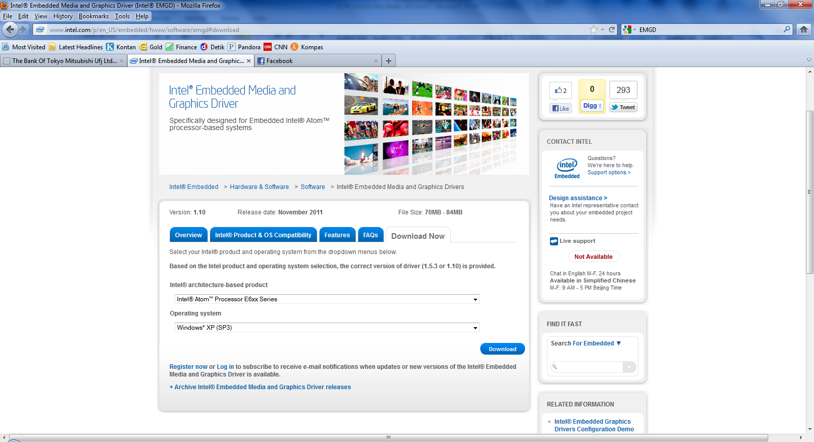

7.2.3 Copy over the zipped file (IEMGD_1_10_GOLD_XP_LINUX_2209) from the USB thumb drive to the Inforce board. Extract the zipped file to the desired location.

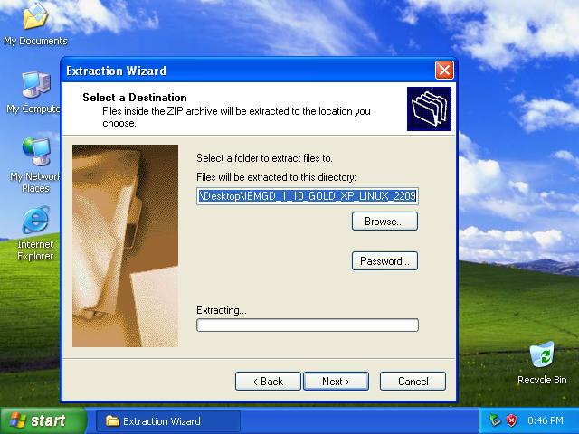

7.2.4 Go to the location where you extract the downloaded files and click on “IEMGD_1_10_GOLD_XP_LINUX_2209” self-extracting installation binary. This will further extract the content of the entire EMGD files.

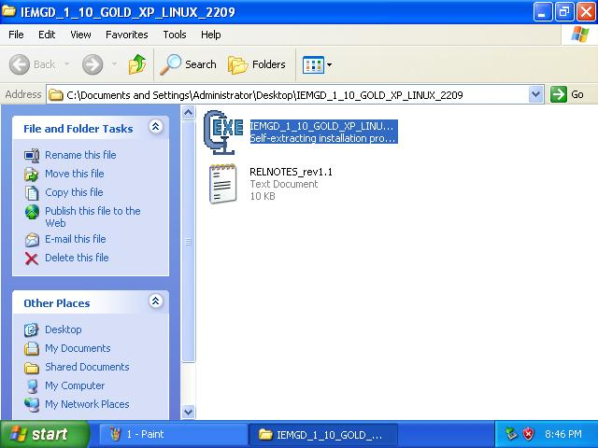

7.2.5 Click on “Yes, I accept the terms of the license agreement” if the user is prompted with several End User License Agreement window.

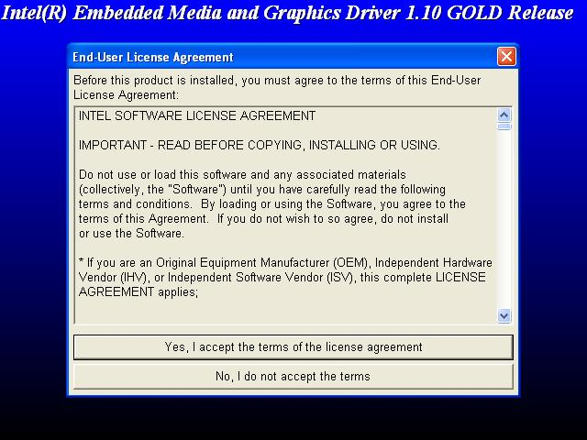

7.2.6 Choose the desired EMGD installation directory by clicking on Browse button. In this example, C:\IEMGD\IEMGD_1_10 folder is shown. Next, click on Continue button to advance.

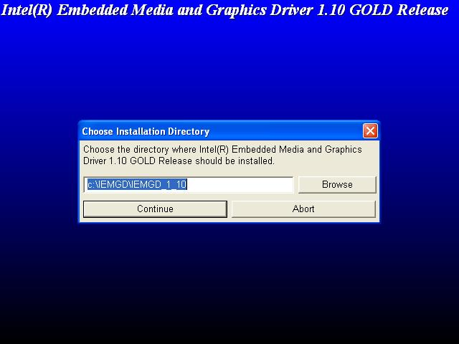

7.2.7 Instead of building the driver using the EMGD CED tool, we will use the EMGD pre-packaged driver for Windows XP SP3. Go to where the user extract the final EMGD files (from step 7.2.6, it’s C:\IEMGD\IEMGD_1_10) and go to “plugins” folder. Go to Pre_Packaged_Drivers_1.10.0 folder and then to Windows folder. Inside Windows folder, extract the zipped file name IEMGD_HEAD_Windows to the desired location.

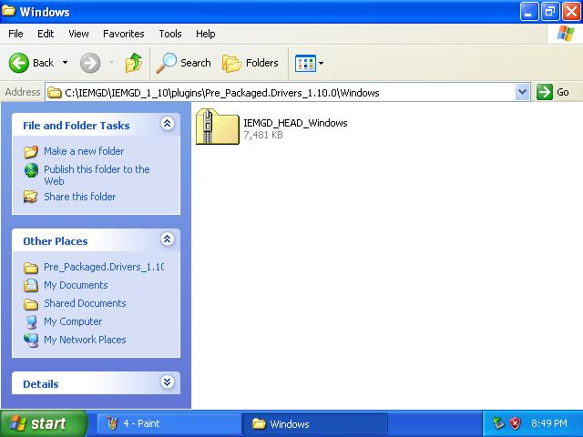

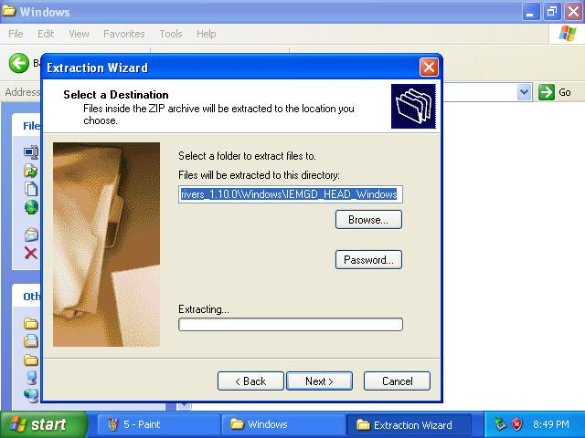

7.2.8 After the EMGD driver files have been extracted, click on “Setup” installer binary to start the EMGD installation process.

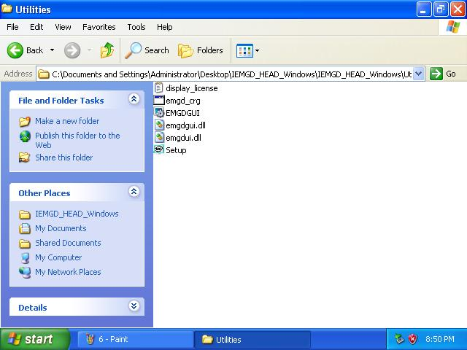

* + 1. Select “Install driver and application files” then click on Next button to start the installation.

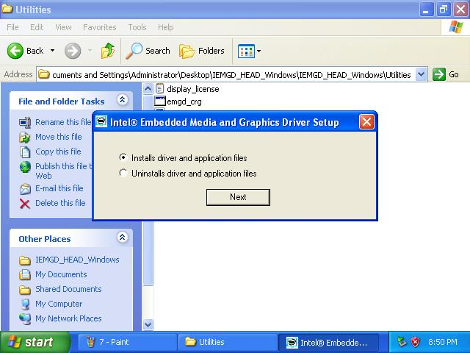

7.2.10 Click on “Continue Anyway” button if the user is prompted with Software Installation warning as shown below. The installation process will take couple minutes and reboot the Inforce system to finish the installation.

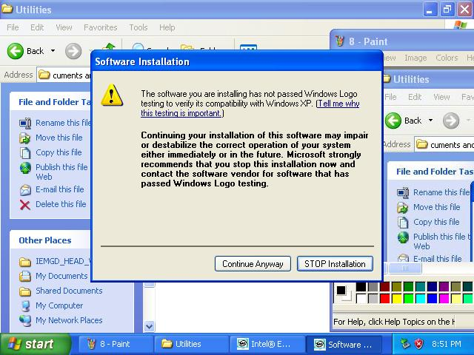

* 1. *Windows XP SP3 EG20T driver installation*

7.3.1 In this section, the user will install EG20T IOH driver for Inforce board in Windows XP SP3. Go to the following link in the host PC to download the latest EG20T driver.

<http://www.intel.com/p/en_US/embedded/hwsw/hardware/atom-e6xx/software>

Plug-in USB thumb drive to the host PC and select “Intel Platform Controller Hub EG20T for Windows XP and Windows Embedded POS Ready” link as shown below.

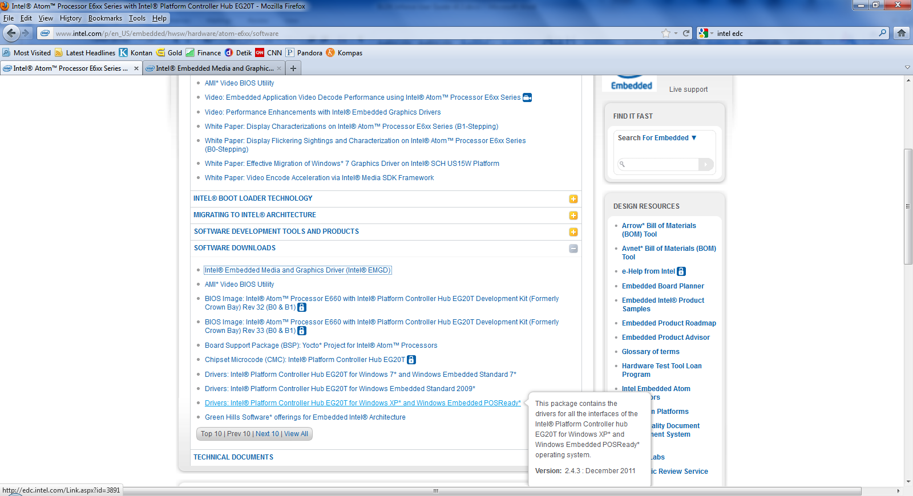

7.3.2 Copy over the GT20 zipped driver files from the USB thumb drive to the Inforce board. Extract the zipped files (EG20T_WinXP_WePOS_Package_243) to the desired location.

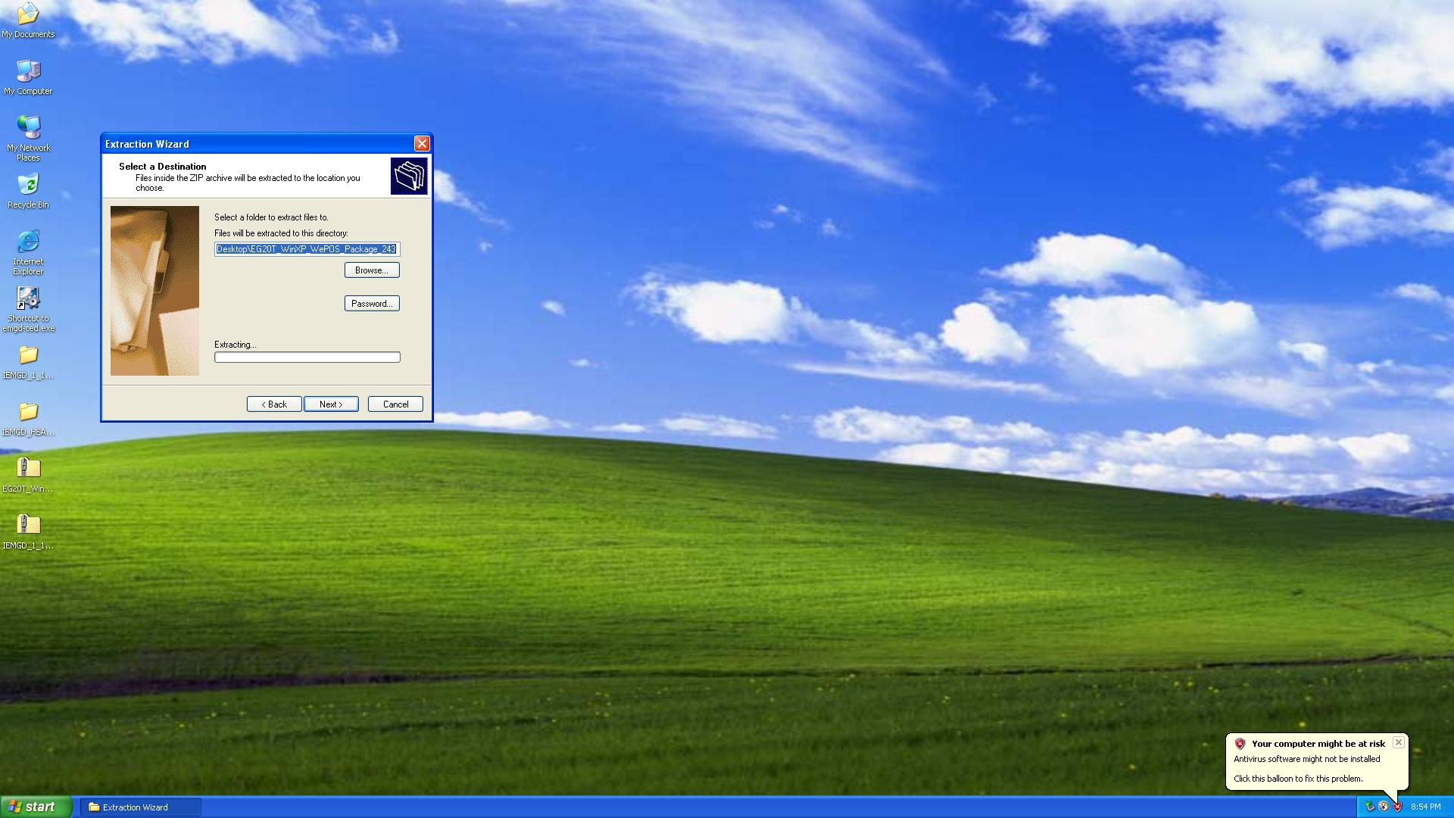

7.3.3 Go to the location where the EG20T driver files are extracted. Click on PCH_EG20T_WinXP_WePOS installer binary to start the IOH driver installation process.

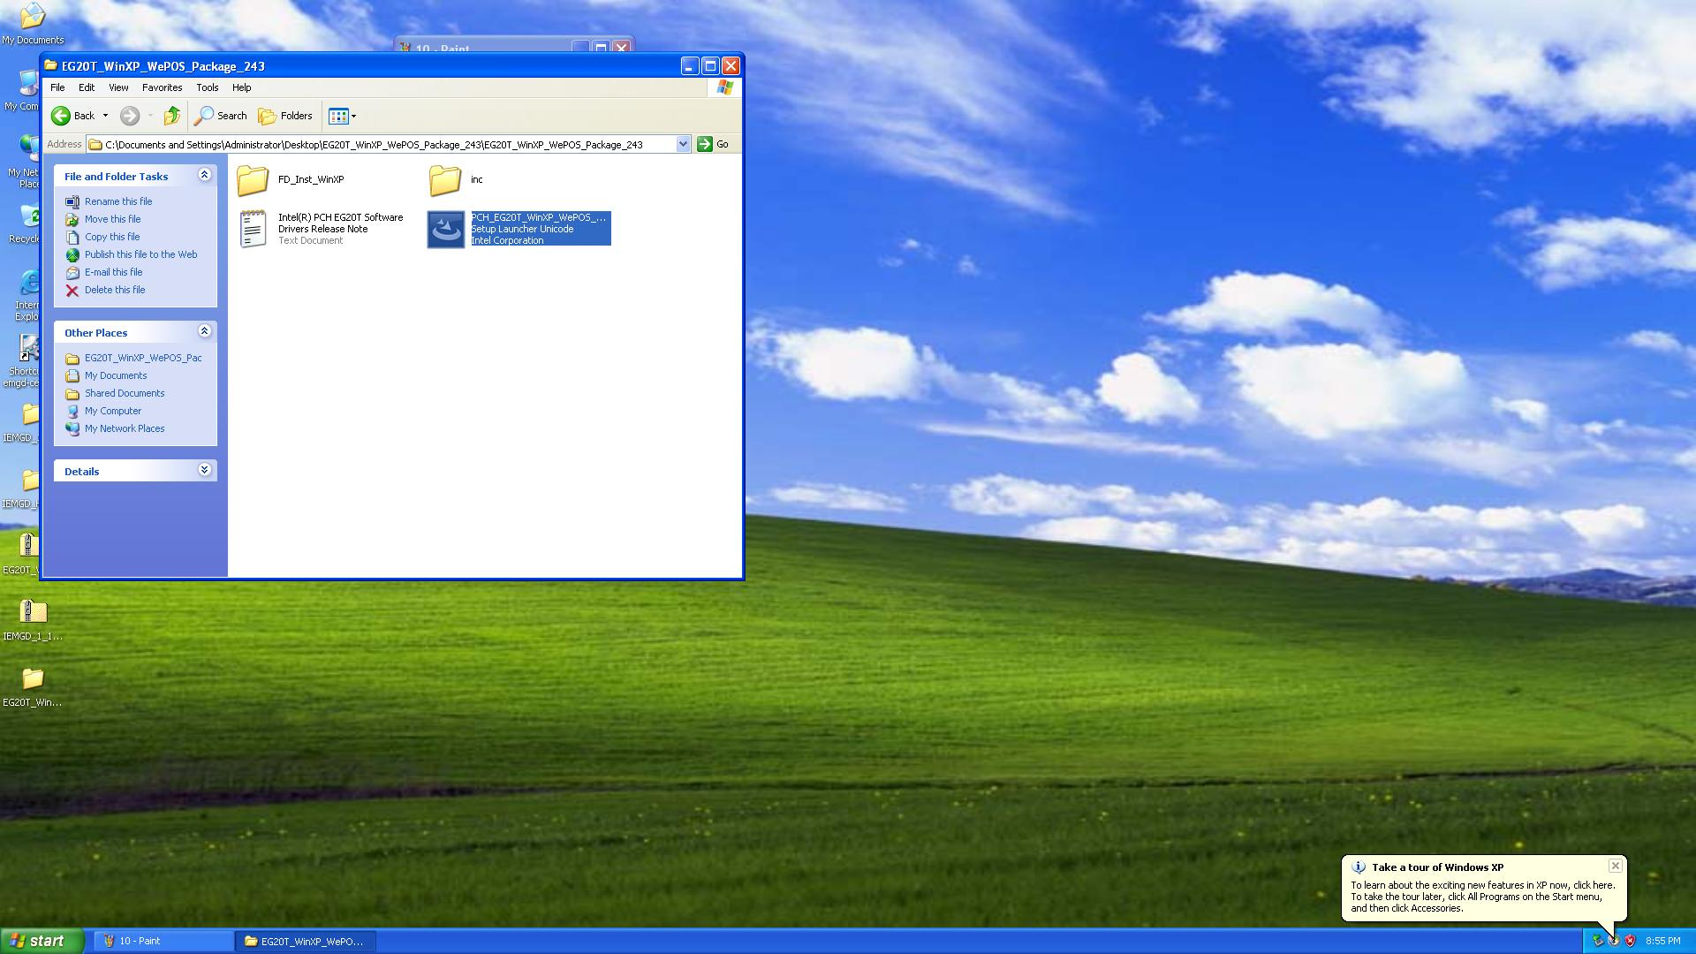

7.3.4 Once the installation process start, the user will see the following images below. Click on to select the software license agreement.

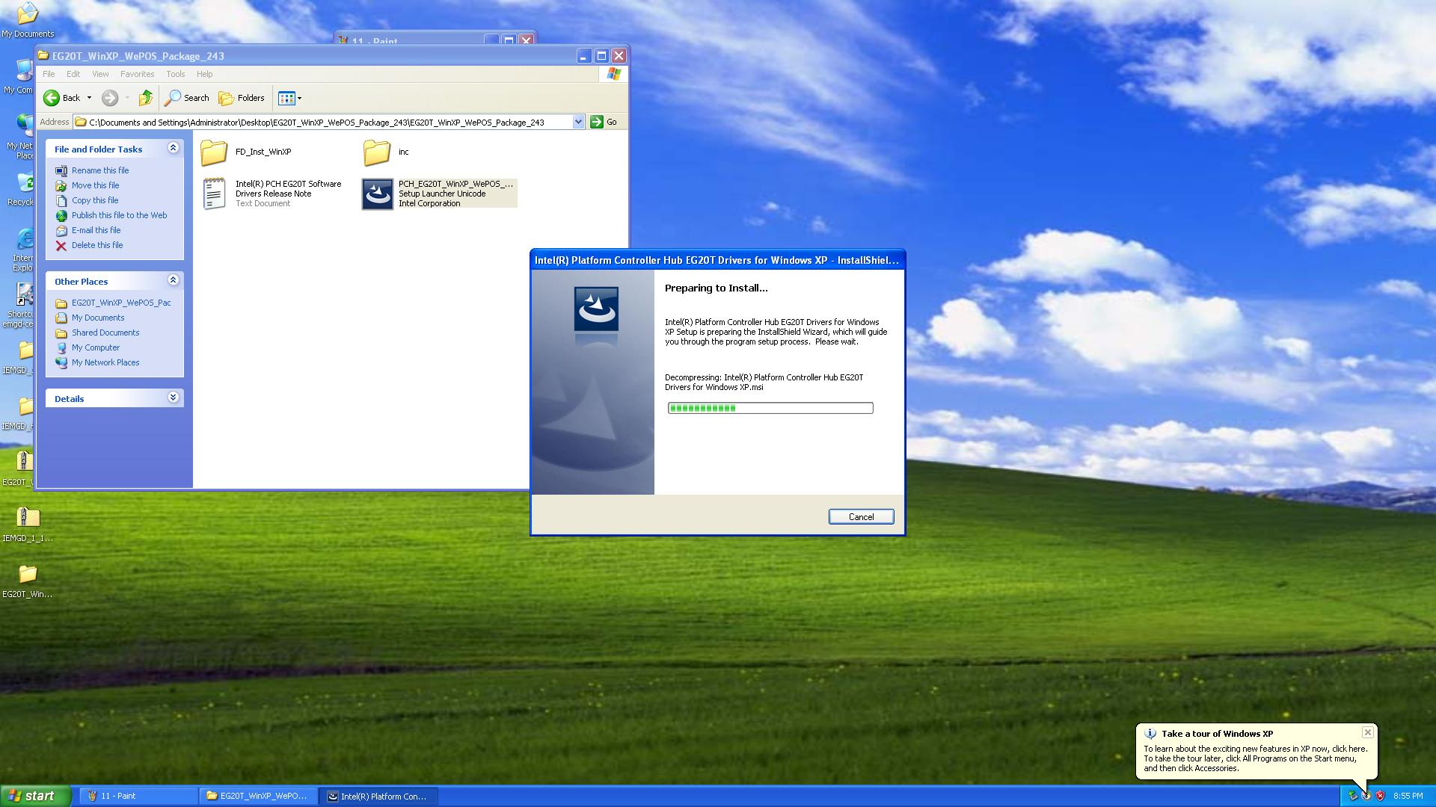

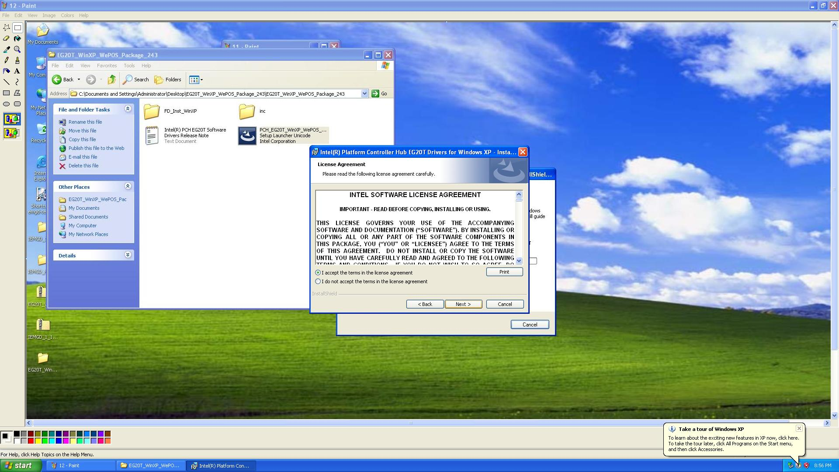

7.3.5 If the user is prompted with several software installation warning, click on Continue Anyway button to finish the installation process. Once the installation finished, reboot the Inforce board to finish the installation.

